BDA Assignment 1

Ayush Yadav 1836420
Nishtha 1905958
Arnav vikas gupta 1905960

Task1
#KEY FIRST_YEAR LAST_YEAR
0 homepages/206/3287 2017.0 2019.0
1 homepages/163/6129 2013.0 2020.0
2 homepages/64/4041 1998.0 1999.0
3 homepages/s/NilsTSiebel 1999.0 2010.0
4 homepages/37/5515 2005.0 2022.0
(438321, 3)
<class 'pandas.DataFrame'>
RangeIndex: 438321 entries, 0 to 438320
Data columns (total 3 columns):
# Column Non-Null Count Dtype
--- ------ -------------- -----
0 #KEY 438321 non-null str
1 FIRST_YEAR 438320 non-null float64
2 LAST_YEAR 438320 non-null float64
dtypes: float64(2), str(1)
memory usage: 10.0 MB
None

--- Span Statistics ---
Min: 0.0
Max: 72.0
Mean: 8.61
Median: 6.0
Q1: 3.0
Q3: 12.0

Full describe:
count 438320.000000
mean 8.610910
std 7.958047
min 0.000000
25% 3.000000
50% 6.000000
75% 12.000000
max 72.000000
Name: SPAN, dtype: float64

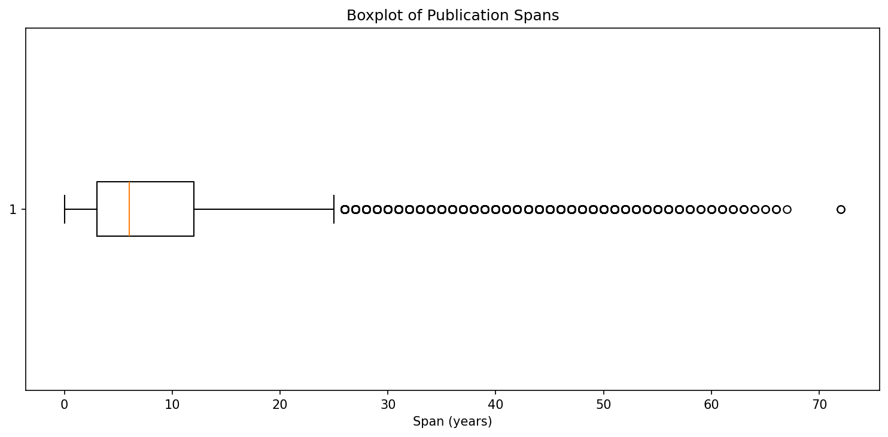

The median span is 6 years and the IQR runs from 3 to 12, meaning most authors have relatively short publishing careers. The distribution is right-skewed, with a long tail of outlier dots stretching out to 72 years, representing a small number of very long-active researchers.
As for issues: the IQR-based whisker rule flags anyone publishing for more than ~25 years as an outlier, even though a long academic career is perfectly normal. The sheer number of outlier dots also makes the plot cluttered and hard to read — a histogram would show the shape of this data much more clearly.

Task2 a

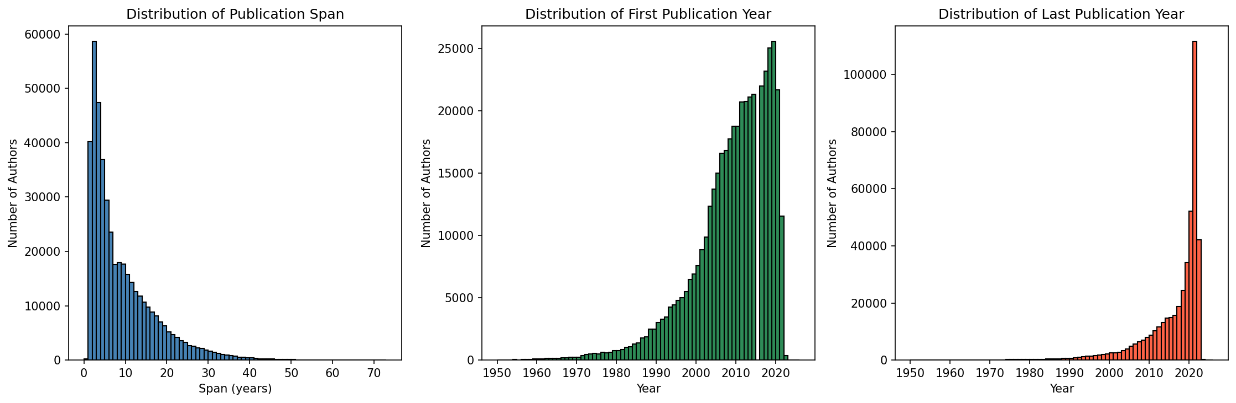

Histogram before filtering

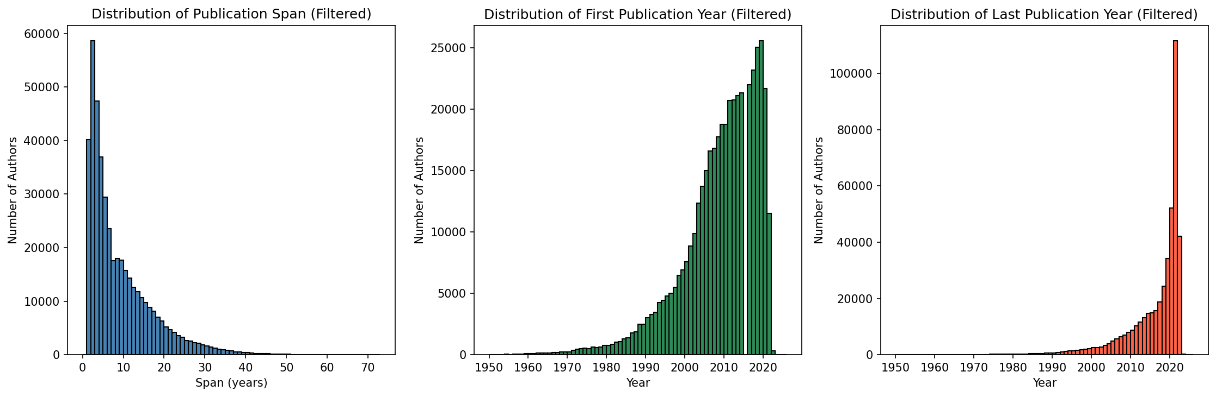

Histogram after filtering

The distributions before and after filtering are visually identical due to the negligible number of removed rows.

For span, we used 73 bins (one per year, range 0–72) since span is integer-valued — each bin represents exactly one year, making the histogram precise and easy to interpret. For FIRST_YEAR and LAST_YEAR, we used one bin per year over the range 1950–2026, as the data is year-based and per-year granularity is natural and meaningful here.

Task2 b
=== BEFORE FILTERING ===
Count: 438321
Mean: 8.61
Median: 6.0
Min: 0.0
Max: 72.0
--- Class 1: Invalid Span (SPAN <= 0) ---
Count: 190
Example:
#KEY FIRST_YEAR LAST_YEAR SPAN
4195 homepages/194/3750 2019.0 2018.0 0.0

--- Class 2: Missing Values (NaN) ---
Count: 1
Example:
#KEY FIRST_YEAR LAST_YEAR SPAN
298064 homepages/w NaN NaN NaN

=== AFTER FILTERING ===
Count: 438130
Mean: 8.61
Median: 6.0
Min: 1.0
Max: 72.0
Removed: 191

A span <= 0 means LAST_YEAR < FIRST_YEAR, which is logically impossible — an author's last publication cannot precede their first. These rows represent data errors in dblp. This manifests in the statistics as min = 0 and in the span histogram as a bar at 0. Removing these rows did not affect the mean because it was insignificant compared to rest of data but these artificially low values could slightly bias the mean downward.

Class 2 — Missing Values (NaN)

One row each is missing FIRST_YEAR and LAST_YEAR. Without both values, a valid span cannot be computed. These rows do not meaningfully affect statistics given the dataset size of 438,321 rows, but must be removed for correctness.

Removing these 191 rows had no visible effect on the histograms and left the mean (8.61) and median (6.0) unchanged, because the discarded rows represent only 0.04% of the dataset. The only meaningful change is that the minimum span corrected from 0 to 1

The average publication span of scientists in this dataset is approximately 8.61 years (after filtering invalid and missing data).

